HTML Slides Notes

12

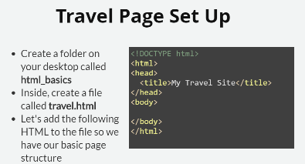

Setup Eclipse project

Create c:\html_basics

Create travel.html, add content if you can

Open Eclipse

Workspace : C:\TTS\eclipse-workspace\html_basics

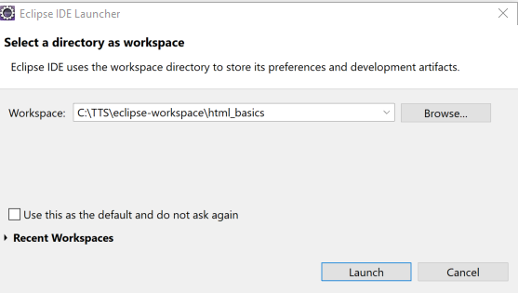

Launch

IDE does way more than we could cover in 6 months, will cover only what we need

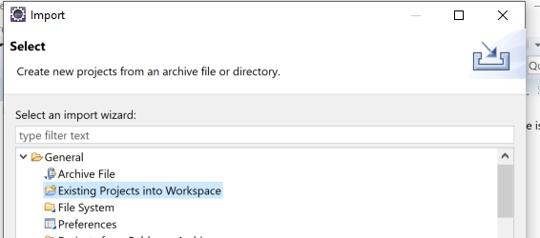

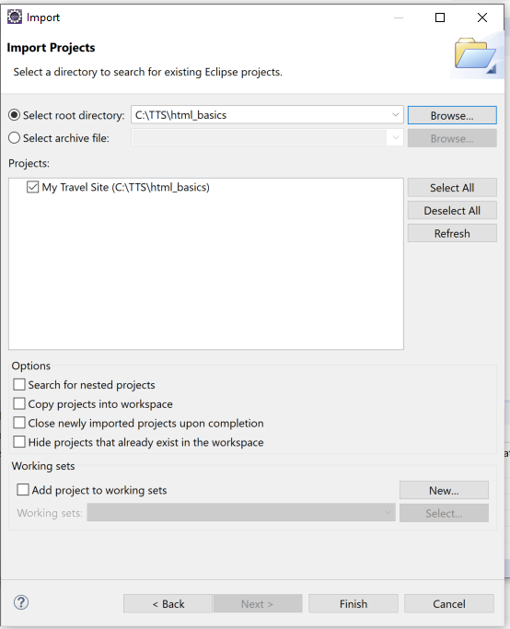

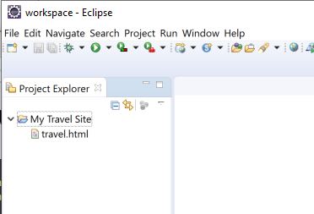

Open travel.html

Right click open with browser

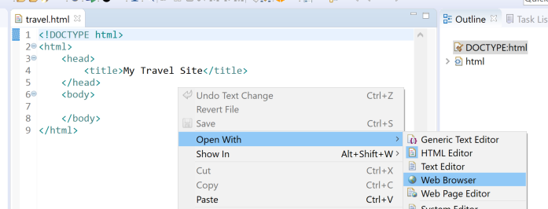

Show how to view with Chrome

Directory on left

Files in center

Outline on right

Server below

Context sensitive editing

Formatting

How to get back to default layout

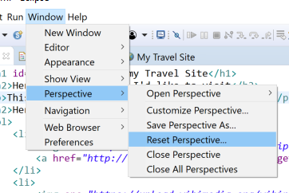

Step through slides offscreen, show my eclipse session.

Build this through slide 20

<!DOCTYPE html>

<html>

<head>

<title>My Travel Site</title>

</head>

<body>

<h1 id=*"top"*>Welcome to my Travel Site</h1>

<h2>Here are some places I'd like to visit</h2>

<p>This site is all about where I want to travel.</p>

<h2>Here are some places I'd like to visit</</h2>

<ol>

<li>Spain</li>

<li>Italy</li>

<li>Aruba</li>

<li>Alaska</li>

</ol>

<a href=*"http://www.google.com"*>Google</a>

<br><br>

<a href=*"http://www.google.com"* target=*"_blank"* >Google in new browser</a>

<br><br>

<a href=*"mailto:csiebsen@techtalentsouth.com"* >Email Chuck</a>

<br><br>

<a href=*"travel-details.html"*>See Details</a>

<br><br>

<a href=*"#top"*>Go to Top</a>

</body>

</html>

Travel-details.html

<!DOCTYPE html>

<html>

<head>

<title>My Travel Details Site</title>

</head>

<body>

<h1>Welcome to Travel Details</h1>

</body>

</html>

CHALLENGE – Add link on details page to go back to main page. >>> <a href="travel.html">Home</a>

Slide 22 add image from TTS

<img height=*"100"* width=*"200"* src=*"https://www.techtalentsouth.com/hubfs/zTTS%20File%20Assets/Navigation/Logos/Template%20Placeholder/logo-full@2x.png"*/>

Slide 23

Add links

<ol>

<li>

<img src=*"https://upload.wikimedia.org/wikipedia/en/thumb/9/9a/Flag_of_Spain.svg/200px-Flag_of_Spain.svg.png"* width=*"100"* height=*"50"*>

<a href=*"http://www.spain.info/en_us/"* target=*"_blank"*>Spain</a>

</li>

<li>

<img src=*"https://upload.wikimedia.org/wikipedia/en/thumb/0/03/Flag_of_Italy.svg/255px-Flag_of_Italy.svg.png"* width=*"100"* height=*"50"*>

<a href=*"http://www.italia.it/en/home.html"* target=*"_blank"*>Italy</a></li>

<li>

<img src=*"https://upload.wikimedia.org/wikipedia/commons/thumb/f/f6/Flag_of_Aruba.svg/250px-Flag_of_Aruba.svg.png"* width=*"100"* height=*"50"*>

<a href=*"http://www.arubatourism.com/"* target=*"_blank"*>Aruba</a></li>

<li>

<img src=*"https://upload.wikimedia.org/wikipedia/commons/thumb/e/e6/Flag_of_Alaska.svg/241px-Flag_of_Alaska.svg.png"* width=*"100"* height=*"50"*>

<a href=*"http://www.travelalaska.com"* target=*"_blank"*>Alaska</a></li>

</ol>

Slide 24-26 Tables

Tables used to be used for page layout, now just for tabular data, due to mobile screens. (Show <https://www.techtalentsouth.com/> wrapping of items on small screen)

Bootstrap lesson covers this in detail

<table

<table>

<tr>

<th>Destination</th>

<th>Capital</th>

<th>Official Language</th>

</tr>

<tr>

<td>Destination</td>

<td>Capital</td>

<td>Official Language</td>

</tr>

<tr>

<td>Spain</td>

<td>Madrid</td>

<td>Spanish</td>

</tr>

<tr>

<td>Italy</td>

<td>Rome</td>

<td>Italian</td>

</tr>

<tr>

<td>Aruba</td>

<td>Oranjestad</td>

<td>Dutch</td>

</tr>

<tr>

<td>Alaska</td>

<td>Juneau</td>

<td>n/a</td>

</tr>

</table>

Slide 27 <div>

Div and span used heavily in CSS and bootstrap.

<div style="background-color: lightblue;">

Wrap links and image at bottom of page

</div>

Slide 28 <span>

<span style="font-style: italic;">

</span>